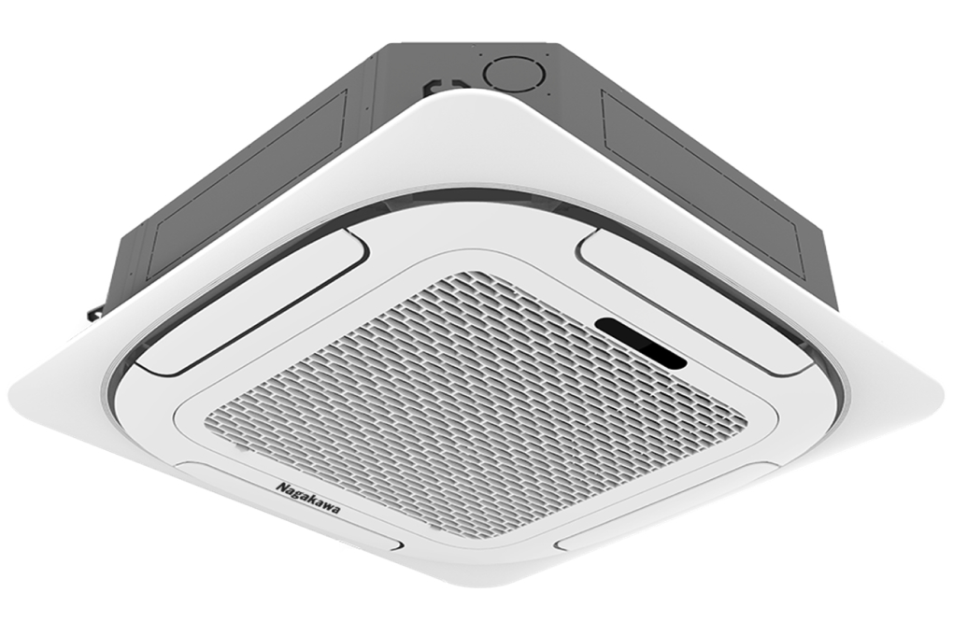

**42.800.000₫**

**Technical specifications of Nagakawa 5 HP ceiling air conditioner NT-C50R1T20**

* Machine Type:

1 way (cooling only) No Inverter

* Cooling capacity:

5 HP - 50000 BTU

* Effective cooling range:

From 60 - 70m² (from 160 - 210m³)

* Dust filter, antibacterial, deodorant:

Dust filter mesh

* Power saving technology:

Eco

* Rapid cooling:

Super

* Utilities:

LED display screen

* Cooler:

Length 84 cm - Height 84 cm - Thickness 29 cm - Weight 28 kg

* Outdoor:

Length 125 cm - Height 94 cm - Thickness 34 cm - Weight 74 kg

Introducing the company 

- Vietnamese brand.  
- Established in 2002.  
- Diverse business products: air conditioners, dishwashers, induction cookers,.... with product prices easily accessible to consumers.  
- Achieved many outstanding achievements: Top 100 best products for families and children (2023), golden brand for Vietnamese health (2019),...

***Nagakawa 5 HP NT-C50R1T20 ceiling air conditioner*** ***is a***[***1-way air conditioner***](https://www.dienmayxanh.com/may-lanh?g=may-lanh-1-chieu-chi-lam-lanh)***with a minimalist ceiling design, saves electricity thanks to Eco technology, protects users' health and brings fresh air thanks to the filter  . dust, Super mode  for quick cooling.***

**Design overview**

**Cooler**

-  Square [air conditioner](https://www.dienmayxanh.com/may-lanh)  has delicate rounded edges, luxurious overall, easy to combine with any interior space, easy to construct and install.

- LED display screen, clearly displays temperature, easy to observe in the dark.

**Outdoor**

- The outdoor unit has a rectangular box design, durable steel shell, effectively resistant to harsh weather.

- Copper gas pipes, hydrophilic-coated aluminum heatsinks are sturdy, have good corrosion resistance, optimally protect the radiator surface, increase cooling capacity, suitable for our country's weather.

**Refrigeration technology**

- Cooling capacity of  **5 HP** , suitable for space areas **from 60 - 70m² (from 160 - 210m³)** .

-  **Super fast cooling mode,**  when activated, will help cool air spread evenly throughout the space quickly, bringing comfort right from the first moment of entering the room.

**Air blowing mechanism**

- This Nagakawa air conditioner has a design of 4 360-degree air vents, the cold air is spread evenly and widely throughout the room, bringing a cool feeling to the user.

**Air filtering ability**

- [Nagakawa ceiling air conditioner](https://www.dienmayxanh.com/may-lanh-nagakawa-am-tran)  is equipped with  **a dust filter**  for basic indoor dust and mold filtering ability, protecting the respiratory system of children and the elderly, providing a fresh and safe space. health for users.

**Power saving technology**

- Eco technology helps [Nagakawa air conditioner](https://www.dienmayxanh.com/may-lanh-nagakawa) compressors operate at low capacity but still ensures optimal cooling efficiency and energy savings.

*Overall,*[*the Nagakawa 5 HP NT-C50R1T20 ceiling air conditioner*](https://www.dienmayxanh.com/may-lanh/am-tran-nagakawa-5-hp-nt-c50r1t20)*has many advantages such as the ability to save electricity thanks to Eco, Super fast cooling, and bring fresh air that is safe for health with a dust filter. The device has a capacity of 5 HP, effective cooling range from 60 - 70m² (from 160 - 210m³).*